Justin Slade

G00409678

CS 435

Fall 2024

Big Data & Cloud Security

AWS Lab Report 5.1

Date: 9/23/2024

Grambling State University

Big Data and Cloud Security

**Purpose or Objective:** Learn how to use AWS Key Management Service by creating keys to encrypt information in a S3

**Procedure/s:**

**Task 1.**

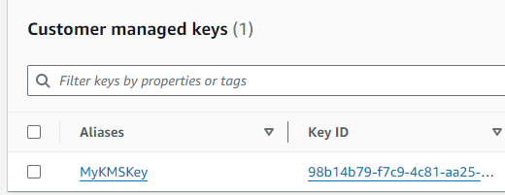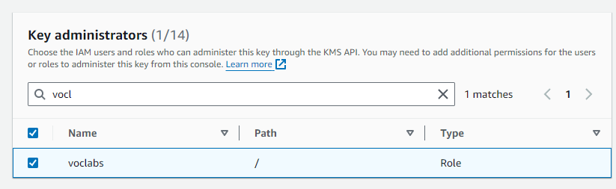I need to create a Key using KMS and assign roles to them for granted authorizations

**Task 2.**

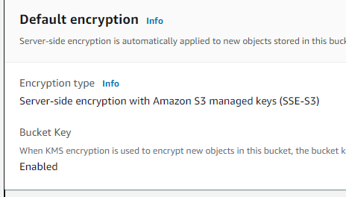Now I need to store a picture within and S3 and secure/encrypt it with the key I made in previous task.

This was disabled, but was supposed to be enabled by default so I fixed that

Lastly I needed to tell my bucket to use the key I made with KMS to allow access to the contents inside.

**Task 3.**

Now I need to access the file from outside my authority, essentially I need to see if the key works without my intervention.

So, I just turn off the setting that is stopping public traffic from accessing it.

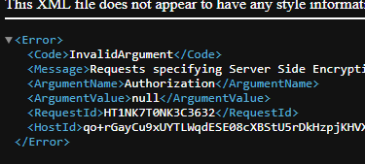Finally we ensure that access is available. Which it does, it just lacks the authorization to do so.

**Task 4.**

Now I’m attempting to gain access to the picture inside the bucket with the key as an authenticated user. Which is simple because I just open the bucket to access the photo that was provided earlier.

However The URL changed substantially showing the massive key used to access the photo inside the bucket. The URL is too big to take a screenshot of…

**Task 5.**

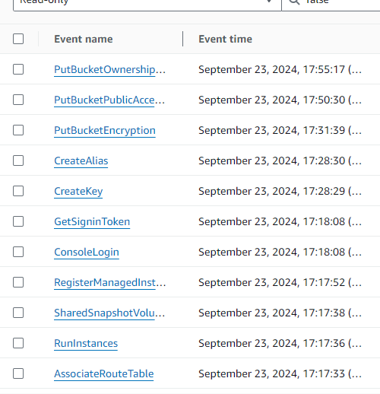I need to access AWS Cloud trail to monitor the activity of whats happening with the key and bucket.

Noticing that it’s shows when exactly I started working on this lab which is funny.

This is Json file noting all of my activities of Key Creation.

**Task 6.**

Now I need to encrypt the EC2 instance but I need to turn it off first since there was one running the entire time to allow for this project to work. I was shocked to see the storage part of the ec2 was not encrypted at all, so this need to get fixed.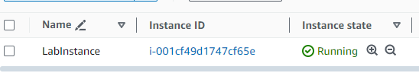

So now I’m going through the process of creating a snapshot to encrypt the storage with the Key I made in the beginning of the lab via the use of Volumes… (ngl im not sure what volumes are but they are needed for this step to allow me to add a key to encrypt my EC2)

Now I have two Volumes and the one currently in use is the unencrypted volume and the one that is available is encrypted and I need to make my EC2 become attached to the available one and detach from the one that is in-use.

**Task 7.**

I need to Disable the keys and to observe how that affects the whole lab. Since we used everything to encrypt involving that key.

Everywhere I go to access the photo, it is broken and inaccessible

However the moment I reenable the key, All issues I had was resolved and everything works again.

**Conclusions:**

This lab has shown me that there many important uses to keys when it comes to encryption and making sure everything that is relies on it stay afloat. In my last task I stripped all of my systems from the key and I couldn’t access anything, but when I enabled the key, Everything resumed as if nothing happened. It’s pretty cool how easy and seamless it is to track every activity as well when it comes to accessing such data and creation of keys and other resources. Really Fun lab

**Knowledge Check (5) Screenshot:**

